**Branches testcases**

**Assembly code:**

.text:

addi x1, x0, 10 #x1 = 10

addi x2, x0, 10 #x2 = 10

beq x1, x2, L1 #BEQ 8

addi x3, x0, -10 # 12

L1:

addi x3, x0, -1 #16

addi x2, x0, -10 #x2 = 0

blt x2, x1, L2 #BLT 24

nop 28

addi x3, x0, -10 32

L2:

addi x3, x0, -2 36

bgt x1, x2, L3 #BGT

nop

addi x3, x0, -10

L3:

addi x3, x0, -3

bne x1, x2, L4 #BNE

nop

addi x3, x0, -10

L4:

addi x3, x0, -4

bge x1, x2, L5

nop

addi x3, x0, -10

L5:

addi x3, x0, -5

addi x1, x0, -7

addi x2, x0, -6

bltu x2, x1, L6

nop

addi x3, x0, -10

L6:

addi x3, x0, -6

bgeu x1, x2, L7

nop

L7:

addi x3, x0, -7

**Hexadecimal:**

93 00 A0 00

13 01 A0 00

63 86 20 00

33 00 00 00

93 01 60 FF

93 01 F0 FF

13 01 60 FF

63 46 11 00

33 00 00 00

93 01 60 FF

93 01 E0 FF

63 46 11 00

33 00 00 00

93 01 60 FF

93 01 D0 FF

63 96 20 00

33 00 00 00

93 01 60 FF

93 01 C0 FF

63 D6 20 00

33 00 00 00

93 01 60 FF

93 01 B0 FF

93 00 90 FF

13 01 A0 FF

63 66 11 00

33 00 00 00

93 01 60 FF

93 01 A0 FF

63 F4 20 00

33 00 00 00

93 01 90 FF

BEQ

At **cycle 6 and 7** the PC output jumped from **12 to 20**

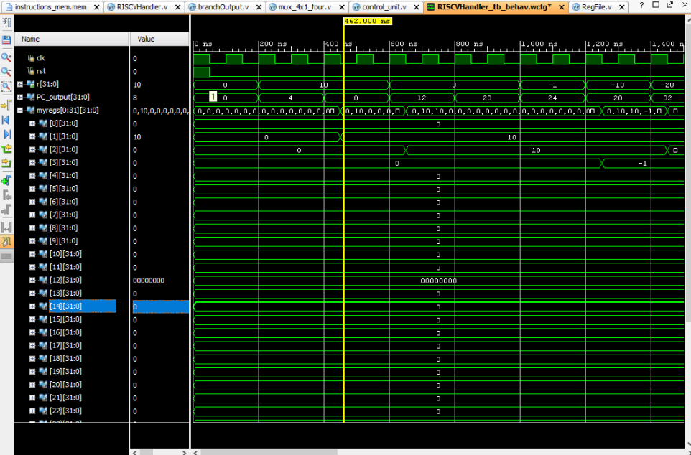

BLT

At **cycle 15 and 16** the PC output jumped from **32 to 40**

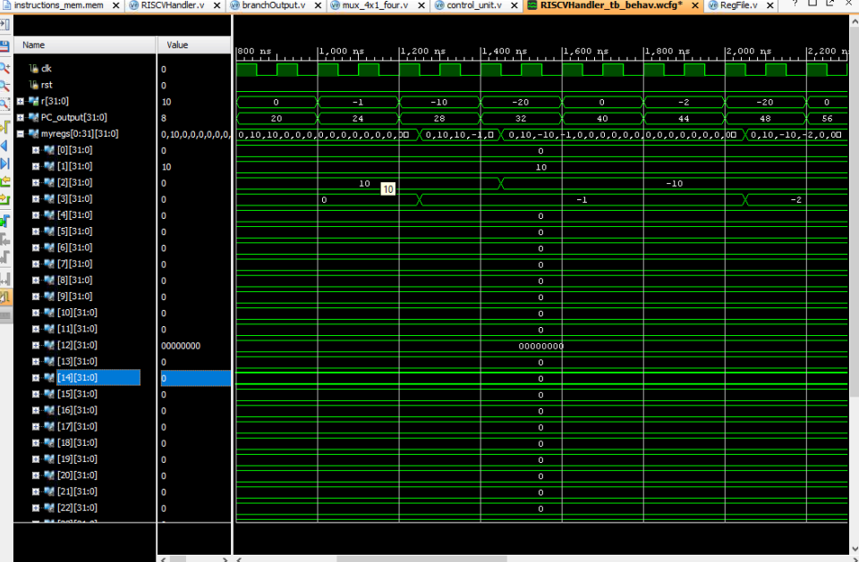

BGT

At **cycle 22 and 23** the PC output jumped from **48 to 56**

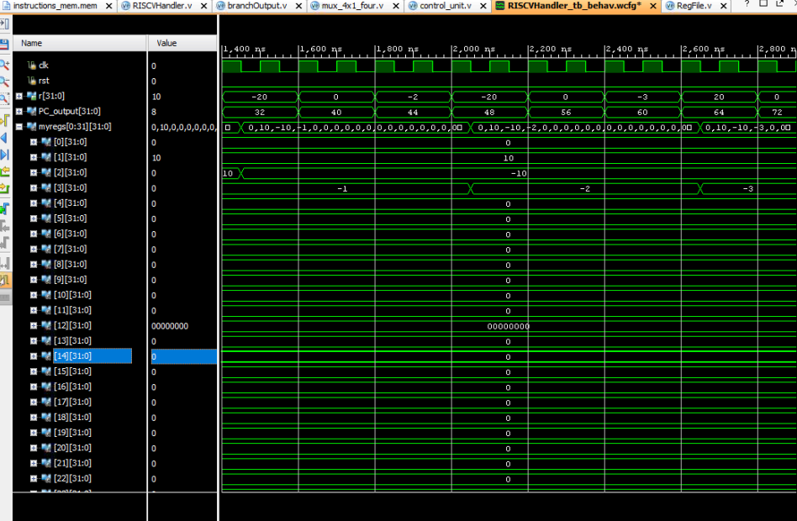

BNE

At **cycle 28 and 29** the PC output jumped from **64 to 72**

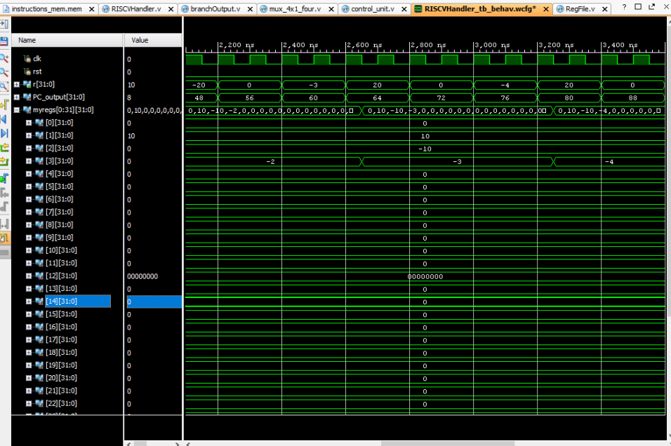

BGE

At **cycle 34 and 35** the PC output jumped from **80 to 88**

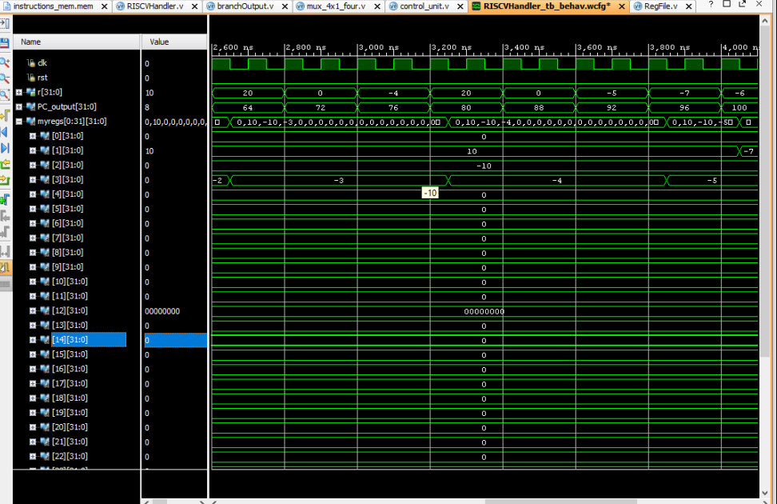

BLTU

At **cycle 44 and 45**, the PC output jumped from **104 to 112**

